J. Sumanth(192312263)

EXPERIMENT 1 :
Simulation-Based Electromagnetic Analysis of TEM, TE and TM Propagation Modes in Microwave Transmission Structures

Aim : To simulate and analyze the WR-90 rectangular waveguide modes (TE₁₀ and TM₁₁) using MATLAB by calculating cutoff frequencies, propagation constant, and electric and magnetic field distributions.

Apparatus Required
- Computer or laptop.
- MATLAB software.
- WR-90 rectangular waveguide parameters (width \(a = 22.86\) mm and height \(b = 10.16\) mm).
- MATLAB program for waveguide mode simulation.

Procedure
- Open MATLAB and create a new script.
- Enter the WR-90 waveguide dimensions, operating frequency, and speed of light.
- Calculate the cutoff frequencies for TE₁₀ and TM₁₁ modes and the TE₁₀ propagation constant.
- Check whether each mode is propagating or evanescent at the operating frequency.
- Plot the electric field, magnetic field, and TE₁₀ propagation characteristics, then run the program and observe the results.

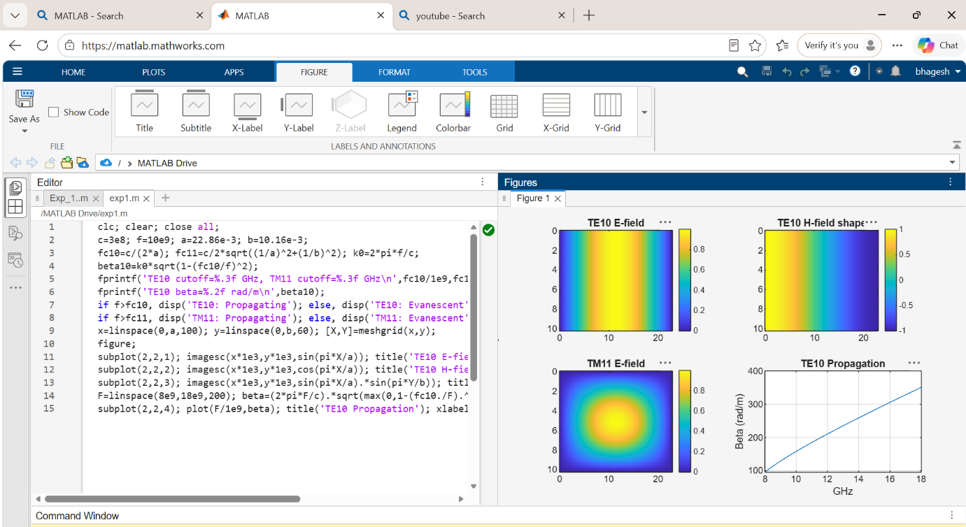
CODE :
clc; clear; close all;
c=3e8; f=10e9; a=22.86e-3; b=10.16e-3;
fc10=c/(2*a); fc11=c/2*sqrt((1/a)^2+(1/b)^2); k0=2*pi*f/c;
beta10=k0*sqrt(1-(fc10/f)^2);
fprintf('TE10 cutoff=%.3f GHz, TM11 cutoff=%.3f GHz\n',fc10/1e9,fc11/1e9);
fprintf('TE10 beta=%.2f rad/m\n',beta10);
if f>fc10, disp('TE10: Propagating'); else, disp('TE10: Evanescent'); end
if f>fc11, disp('TM11: Propagating'); else, disp('TM11: Evanescent'); end
x=linspace(0,a,100); y=linspace(0,b,60); [X,Y]=meshgrid(x,y);
figure;
subplot(2,2,1); imagesc(x*1e3,y*1e3,sin(pi*X/a)); title('TE10 E-field'); colorbar;
subplot(2,2,2); imagesc(x*1e3,y*1e3,cos(pi*X/a)); title('TE10 H-field shape'); colorbar;
subplot(2,2,3); imagesc(x*1e3,y*1e3,sin(pi*X/a).*sin(pi*Y/b)); title('TM11 E-field'); colorbar;
F=linspace(8e9,18e9,200); beta=(2*pi*F/c).*sqrt(max(0,1-(fc10./F).^2));
subplot(2,2,4); plot(F/1e9,beta); title('TE10 Propagation'); xlabel('GHz'); ylabel('Beta (rad/m)'); grid on;

OUTPUT :

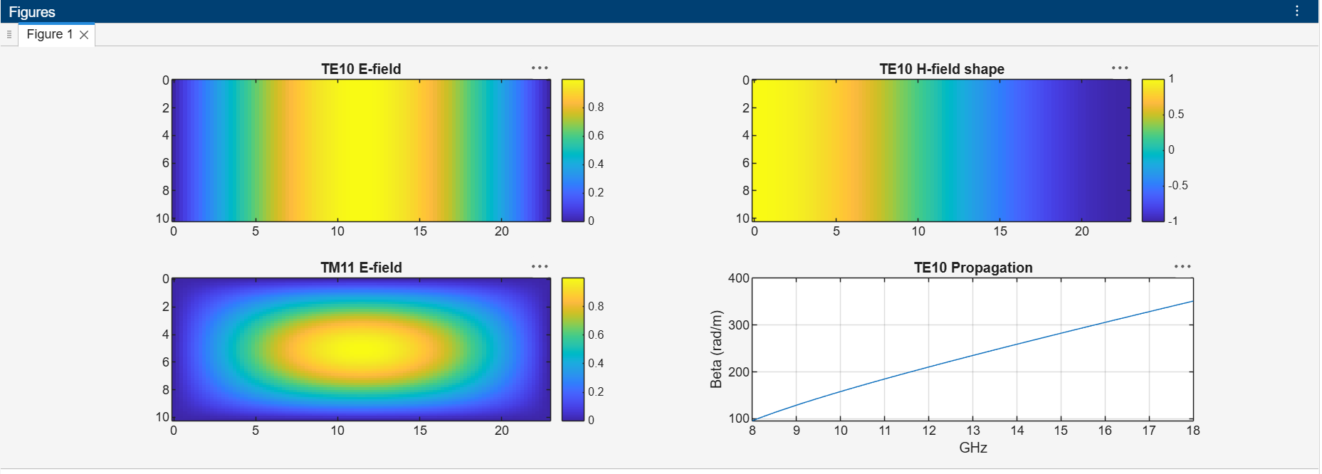
Reflection :
The MATLAB simulation helps us understand the operating characteristics of a rectangular waveguide. The cutoff frequency determines whether a mode can propagate or becomes evanescent. The field plots show the field distribution inside the waveguide, while the propagation graph illustrates how the propagation constant varies with frequency.
Result :
The WR-90 rectangular waveguide modes were successfully simulated using MATLAB. The TE₁₀ cutoff frequency was found to be approximately 6.562 GHz, and the TM₁₁ cutoff frequency was approximately 18.10 GHz. At the operating frequency of 10 GHz, the TE₁₀ mode propagates, while the TM₁₁ mode is evanescent. The field distributions and propagation characteristics were plotted successfully.

